

[ **Task 1 – (Penguins)]**

***Neural Networks & deep Learning***

***Scientific Computing Department***

***Faculty Of Computer and Information Science***

***Ain Shams University***



|  |  |  |  |
| --- | --- | --- | --- |
| Name | ID | Section | Emails |
| Osama Anter Mohamed | 20191700091 | 1 | osama20191700091@cis.asu.edu.eg |
| Ahmed Mohamed Ibrahim | 20191700059 | 1 | ahmed20191700059@cis.asu.edu.eg |
| Adham Mohamed Tawfik | 20191700086 | 1 | adham20191700086@cis.asu.edu.eg |
| Ahmed Mohamed Ali | 20191700068 | 1 | ahmed20191700068@cis.asu.edu.eg |
| Tarek Ashraf Mahmoud | 20191700322 | 3 | tarek20191700322@cis.asu.edu.eg |

**Sdreen Shoots:**

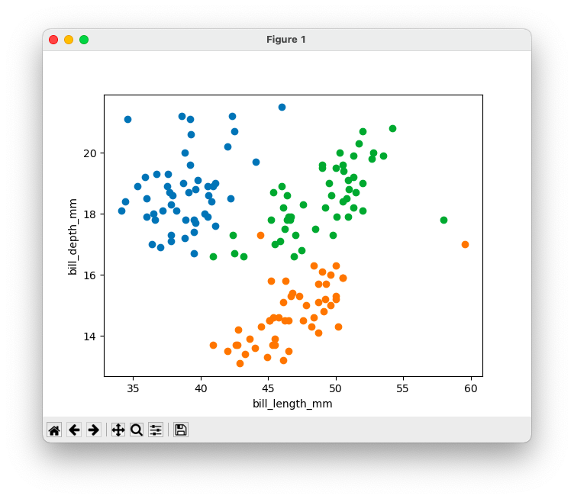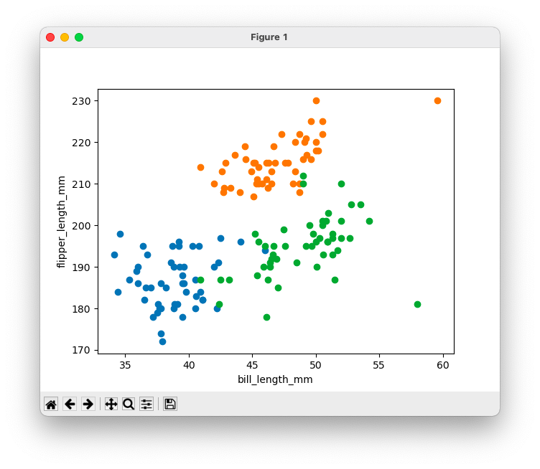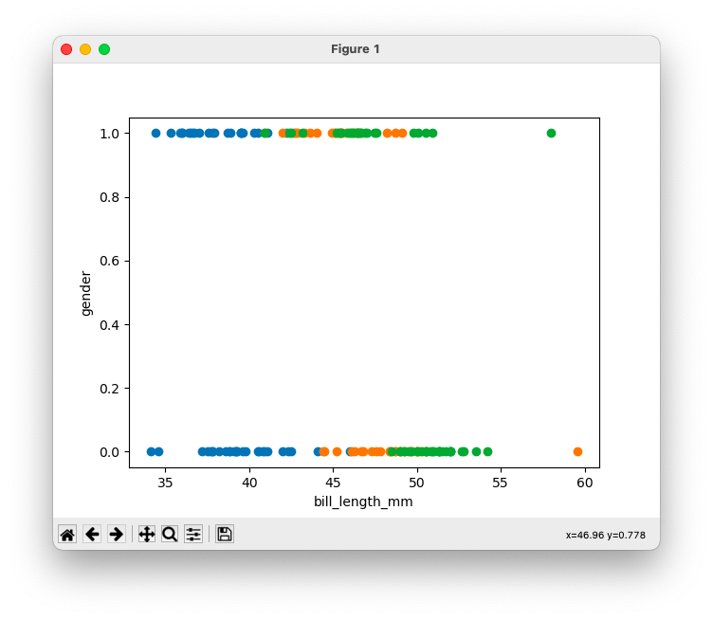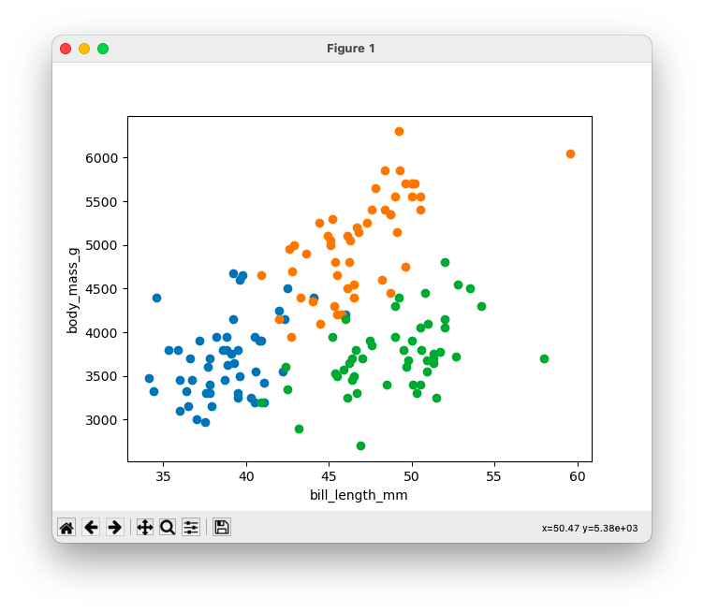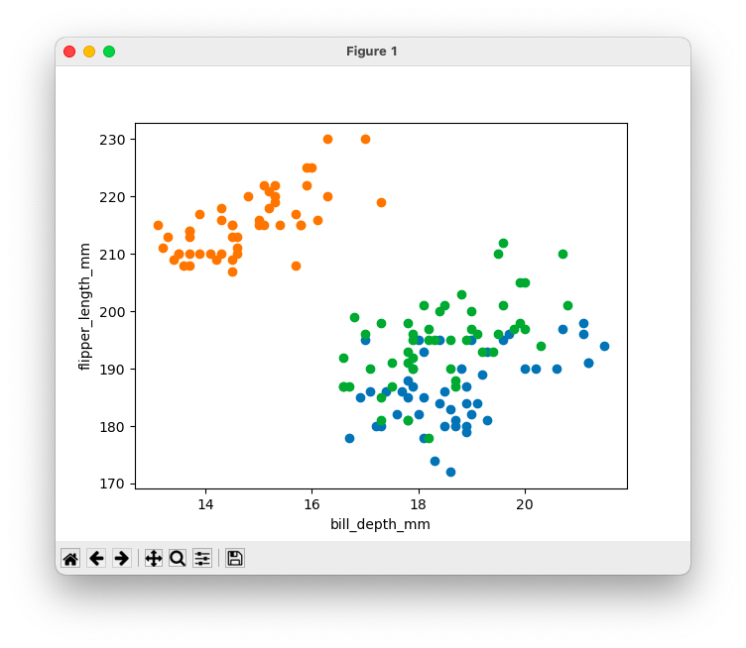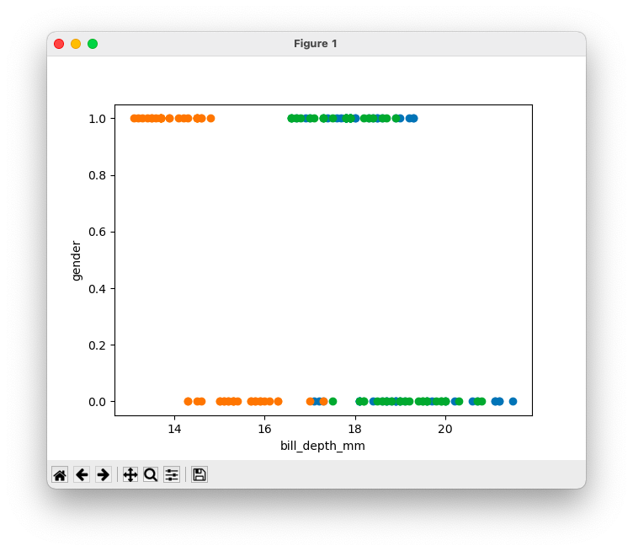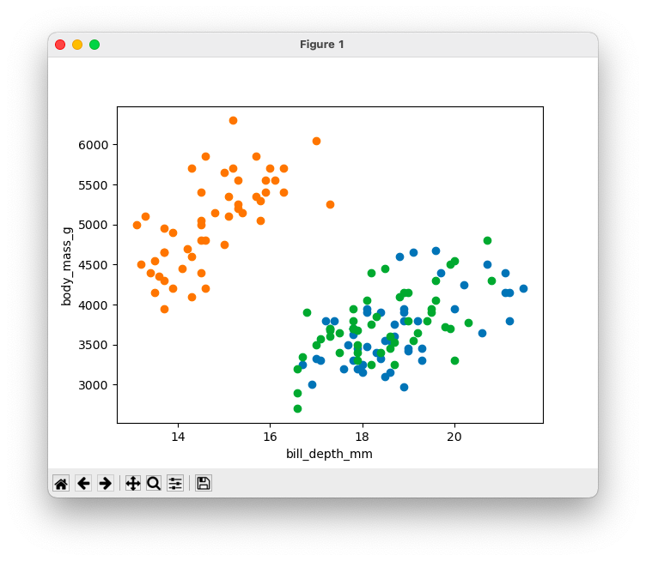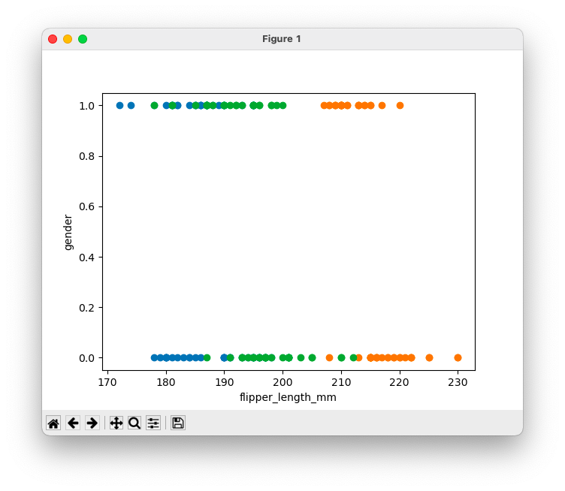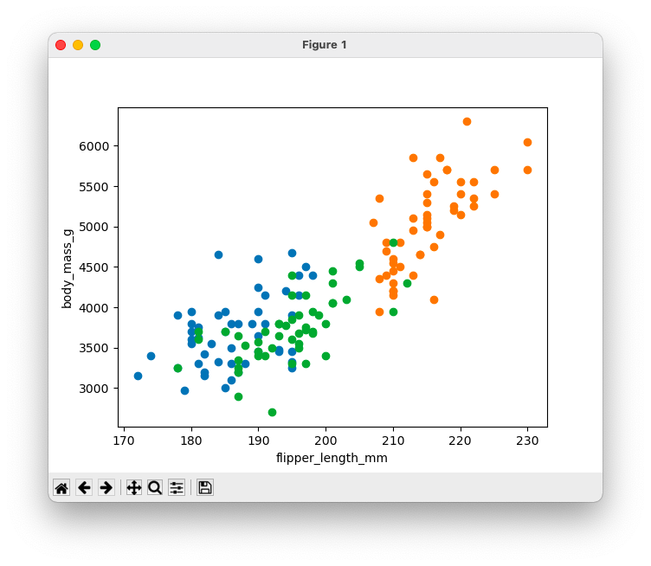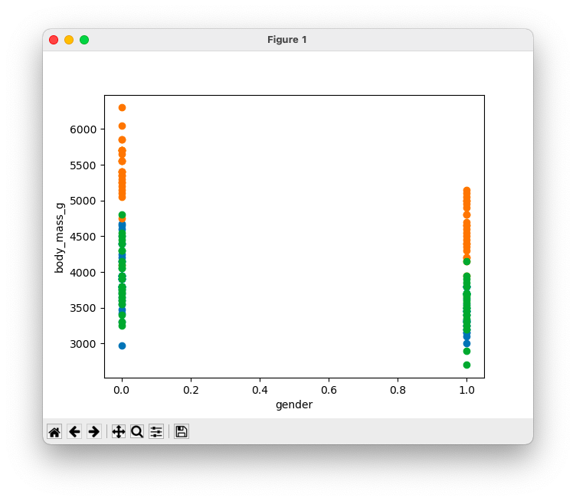

* **classes (Adelie, Gentoo):**
  + **features (bill_length_mm, bill_depth_mm) 🡪 accuracy (1.0)**
  + features (bill_length_mm, flipper_length_mm) 🡪 accuracy (0.55)
  + features (bill_length_mm, gender) 🡪 accuracy (0.425)
  + features (bill_length_mm, body_mass_g) 🡪 accuracy (0.425)
  + features (bill_depth_mm, flipper_length_mm) 🡪 accuracy (0.975)
  + features (bill_depth_mm, gender) 🡪 accuracy (0.95)
  + features (bill_depth_mm, body_mass_g) 🡪 accuracy (0.45)
  + features (flipper_length_mm, gender) 🡪 accuracy (0.55)
  + features (flipper_length_mm, body_mass_g) 🡪 accuracy (0.475)
  + features (gender, body_mass_g) 🡪 accuracy (0.45)
* **classes (Adelie, Chinstrap):**
  + **features (bill_length_mm, bill_depth_mm) 🡪 accuracy (1.0)**
  + features (bill_length_mm, flipper_length_mm) 🡪 Accuracy (0.975)
  + features (bill_length_mm, gender) 🡪 accuracy (0.6)
  + features (bill_length_mm, body_mass_g) 🡪 accuracy (0.45)
  + features (bill_depth_mm, flipper_length_mm) 🡪 accuracy (0.475)
  + features (bill_depth_mm, gender) 🡪 accuracy (0.45)
  + features (bill_depth_mm, body_mass_g) 🡪 accuracy (0.375)
  + features (flipper_length_mm, gender) 🡪 accuracy (0.475)
  + features (flipper_length_mm, body_mass_g) 🡪 accuracy (0.475)
  + features (gender, body_mass_g) 🡪 accuracy (0.475)
* **classes (Gentoo, Chinstrap):**
  + features (bill_length_mm, bill_depth_mm) 🡪 accuracy (0.575)
  + features (bill_length_mm, flipper_length_mm) 🡪 accuracy (0.875)
  + features (bill_length_mm, gender) 🡪 accuracy (0.55)
  + features (bill_length_mm, body_mass_g) 🡪 accuracy (0.925)
  + **features (bill_depth_mm, flipper_length_mm) 🡪 accuracy (1.0)**
  + features (bill_depth_mm, gender) 🡪 accuracy (0.975)
  + features (bill_depth_mm, body_mass_g) 🡪 accuracy (0.55)
  + features (flipper_length_mm, gender) 🡪 accuracy (0.525)
  + features (flipper_length_mm, body_mass_g) 🡪 accuracy (0.8)
  + features (gender, body_mass_g) 🡪 accuracy (0.5)

**analsis:**

* The best accuracy between classes **(Gentoo, Chinstrap)** with features (bill_depth_mm, flipper_length_mm)
* The best accuracy between classes **(ADELIE, GENTOO)**

with features (BILL_LENGTH_MM, BILL_DEPTH_MM)

* The best accuracy between classes **(Adelie, Chinstrap)**

with features (bill_length_mm, bill_depth_mm)

Thank You :)